**School of Electrical & Computer Engineering**

**2022 - 23**

**Project Report**

**On**

**RAIN WATER TRAPPING**

Submitted by

**29_Shreerang Mhatre**

**63_Mukund Narsaria**

**66_Sarvesh Gurav**

**53_Aditya Vishwaraj**

**26_Sakshi Vetotskar**

**in**

**Data Structures and Algorithms**

**SY B. Tech**

**Under the Guidance of (Mrs.Bhagayalaxmi)**

**Table of Contents**

|  |  |
| --- | --- |
| **Acknowledgement** | |
| **CH. 1** | **Introduction** |
| **CH. 2** | **Problem statement** |
| **CH. 3** | **Data Structure Used** |
| **CH. 4** | **Algorithm** |
| **CH. 5** | **Results** |
| **CH. 6** | **Conclusion** |
| **CH. 7** | **References** |

1. **Introduction:**

DSA, or Data Structures and Algorithms, is a field of computer science that deals with the

design and implementation of efficient data structures and algorithms. While DSA may not be directly related to the physical process of trapping rainwater, it can be used to design algorithms for simulating and optimizing rainwater trapping systems.

One example of using DSA for rainwater trapping is optimizing the placement of rainwater

collection tanks in a given area. This can be modeled as a graph problem, where the nodes represent potential tank locations and the edges represent the distance between them. By using algorithms such as Dijkstra's algorithm or A* search, the optimal placement of tanks can be determined based on factors such as distance to rooftops, surface runoff areas, and stormwater drains.

Another example is using data structures such as arrays, linked lists, and stacks to efficiently store and process data from rain gauges and other sensors that measure the amount and

intensity of rainfall. This data can be used to predict the timing and quantity of rainwater runoff, which in turn can be used to optimize the size and capacity of rainwater collection systems.

In summary, DSA can be used to design and optimize rainwater trapping systems by modeling them as graph problems and efficiently processing data from sensors and other sources.

1. **PROBLEM STATEMENT:**

Given an array of N non-negative integers arr[ ] representing an elevation map where the width of each bar is 1, compute how much water it is able to trap after raining.

1. **Algorithm:**
2. **Codes:**

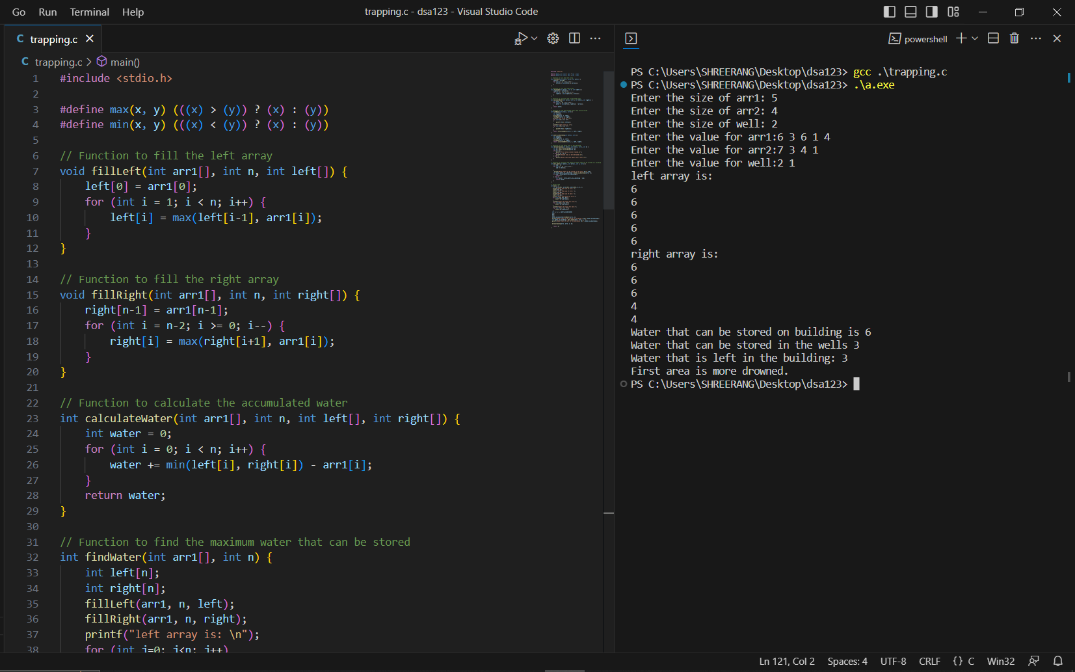

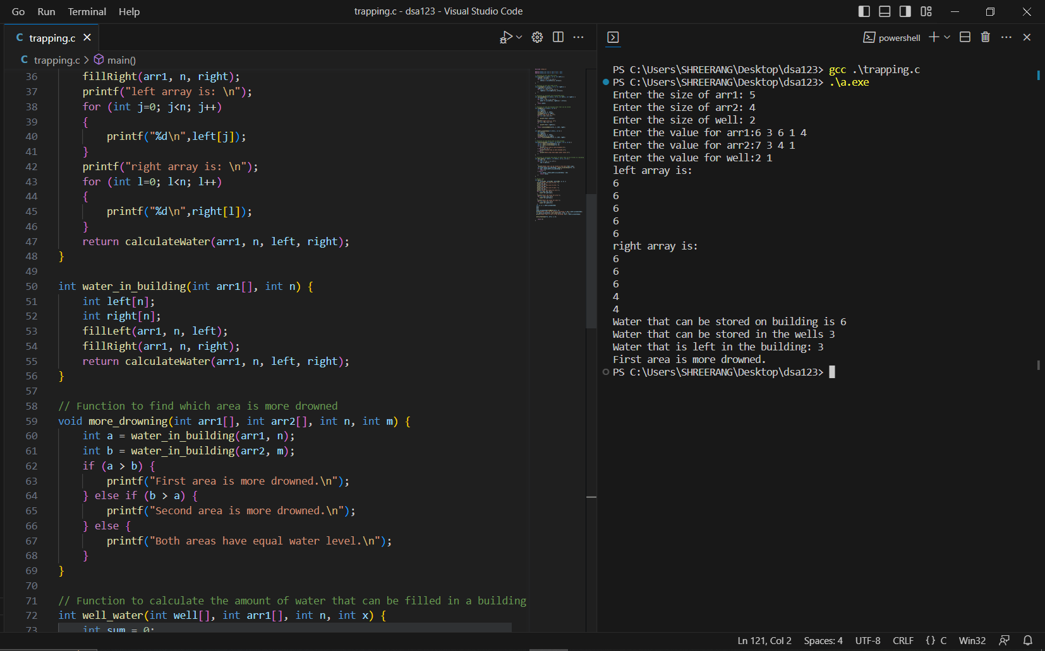

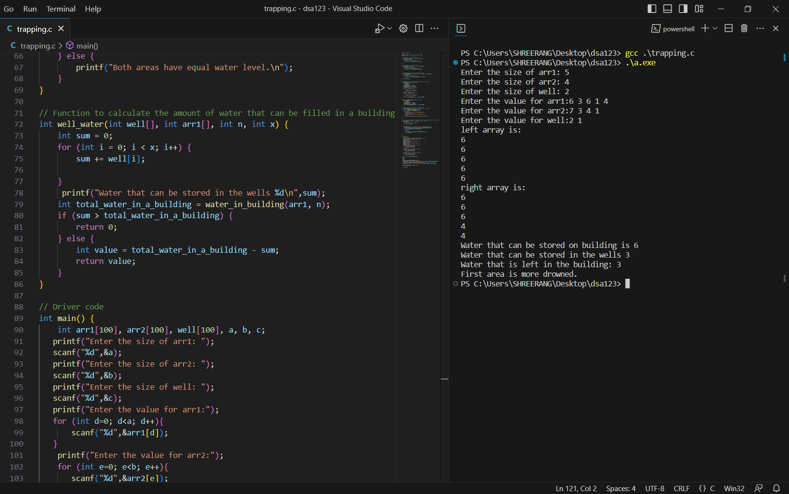

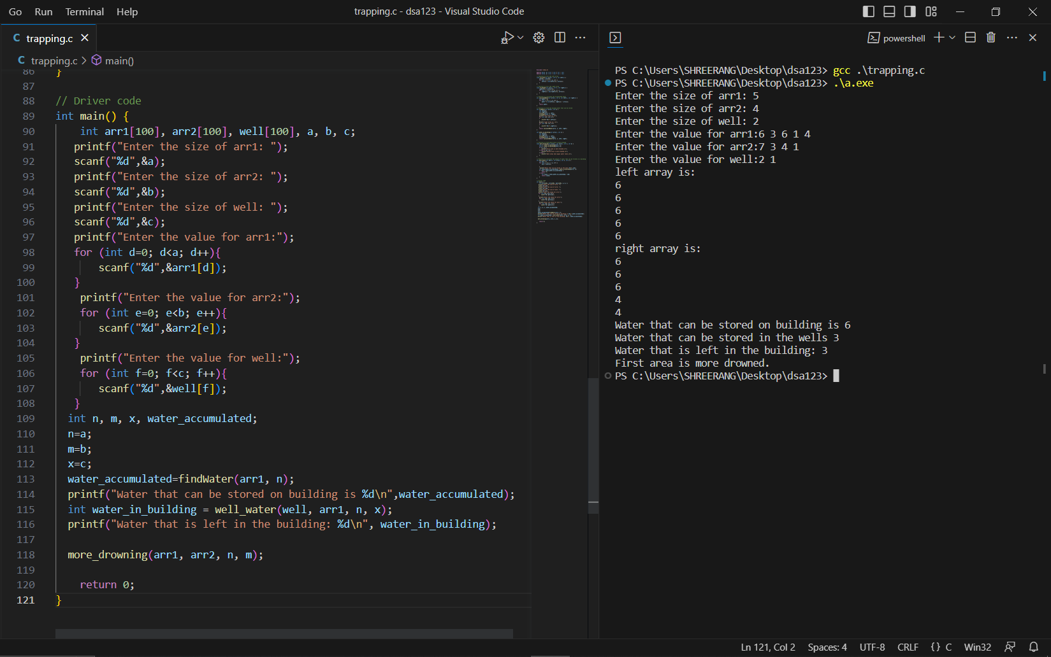

1. 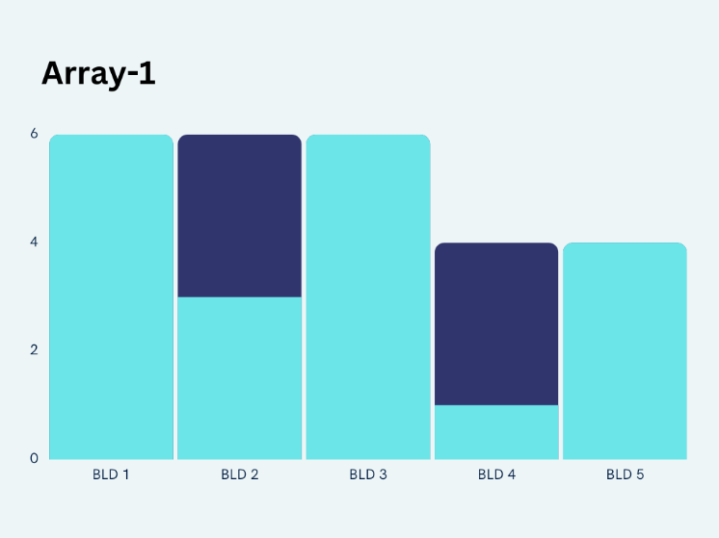**RESULTS:**

Enter the size of arr1: 5

Enter the size of arr2: 4

Enter the size of well: 2

Enter the value for arr1:6 3 6 1 4

Enter the value for arr2:7 3 4 1

Enter the value for well:2 1

left array is:

6

6

6

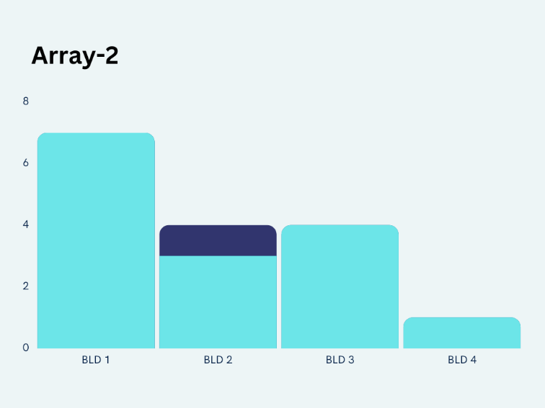6

6

right array is:

6

6

6

4

4

Water that can be stored on building is 6

Water that can be stored in the wells 3

Water that is left in the building: 3

First area is more drowned.

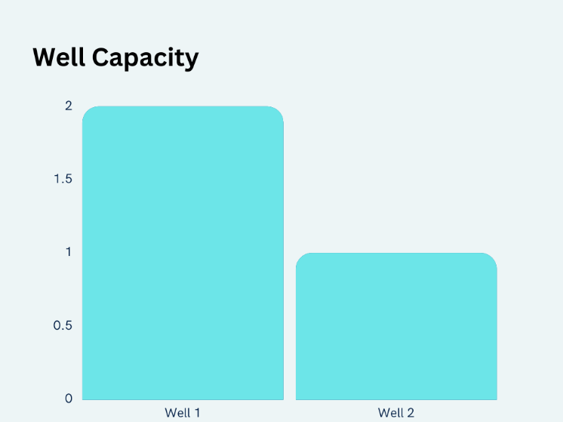

1. **CONCLUSION:**

The benefits of collecting rainwater are numerous. It reduces the demand on the municipal water supply. It allows for storage of seasonal rains for use in off-peak times. Harvesting systems reduce erosion, property flooding, and contamination by reducing the majority of runoff from businesses and homes.

1. **References:**

[**https://www.geeksforgeeks.org/learn-data-structures-and-algorithms-dsa-tutorial/**](https://www.geeksforgeeks.org/learn-data-structures-and-algorithms-dsa-tutorial/)

[**https://www.programiz.com/dsa**](https://www.programiz.com/dsa)

[**https://www.tutorialspoint.com/data_structures_algorithms/index.htm**](https://www.tutorialspoint.com/data_structures_algorithms/index.htm)

[**https://www.youtube.com/playlist?list=PL9gnSGHSqcnr_DxHsP7AW9ftq0AtAyYqJ**](https://www.youtube.com/playlist?list=PL9gnSGHSqcnr_DxHsP7AW9ftq0AtAyYqJ)

[**https://www.geeksforgeeks.org/array-data-structure/**](https://www.geeksforgeeks.org/array-data-structure/)

[**https://www.simplilearn.com/tutorials/data-structure-tutorial/arrays-in-data-structure**](https://www.simplilearn.com/tutorials/data-structure-tutorial/arrays-in-data-structure)

[**https://www.javatpoint.com/data-structure-array**](https://www.javatpoint.com/data-structure-array)

[**https://www.youtube.com/watch?v=5_5oE5lgrhw&ab_channel=CodeWithHarry**](https://www.youtube.com/watch?v=5_5oE5lgrhw&ab_channel=CodeWithHarry)